**In ROAR, part 2 we will receive a ROAR formatted in JSON from the Internet.**

Level of difficulty:   
Estimated time: 10 mn

[**www.codapps.io**](http://www.codapps.io)by Clement Levallois **@codapps_io** [**www.coursera.org/learn/codapps**](http://www.coursera.org/learn/codapps)



**Module 7: ROAR, part 2**

*You need to add this to your app to get JSON to work*

* The ROAR will be formatted in JSON. **But** our app does not know yet how to create objects, and boxes, which can manipulate JSON (like, reading JSON titles or values… I let you look back to the module 6 and the lesson about JSON)
* **So, we need to add to our app a little plugin which will enable it to work with JSON. Let’s do it in 4 quick steps** :

1. Download this plugin and save it in a place easy to find on your computer :

[JSON plugin](https://dl.dropboxusercontent.com/u/28091845/coursera/codapps/files/json-20150729.jar)

1. On your computer, open the folder of your NetBeans project (here my project is called « Roar »). Place the file your just downloaded in the « lib » folder :

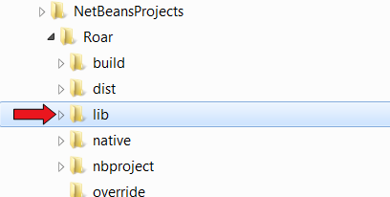

1. Open NetBeans. In your project, **right click** (don’t left click) on the « Libraries » folder :

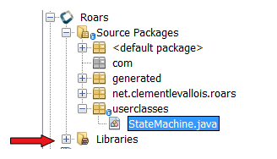

1. Choose **« Add JAR/Folder »** and in the file finder that opens, find and select the file you just placed in the lib folder in step 3. Done, you can now use JSON objects in your app !

[**www.codapps.io**](http://www.codapps.io)by Clement Levallois **@codapps_io** [**www.coursera.org/learn/codapps**](http://www.coursera.org/learn/codapps)



[**www.codapps.io**](http://www.codapps.io)by Clement Levallois **@codapps_io** [**www.coursera.org/learn/codapps**](http://www.coursera.org/learn/codapps)



[**www.codapps.io**](http://www.codapps.io)by Clement Levallois **@codapps_io** [**www.coursera.org/learn/codapps**](http://www.coursera.org/learn/codapps)

